1. **<https://github.com/rvsp/typescript-oops/blob/master/Practice/Movie.md>**

class Movie {

constructor(title,studio,rating="PG"){

this.title = title;

this.studio = studio;

this.rating = rating;

}

getPG(arr){

var result = arr.filter(array =>array.includes(this.rating));

return result;

}

}

const movie1 = new Movie("Casino Royale","Eon Productions","PG13");

console.log(movie1);

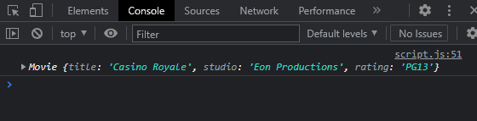

1. [**https://github.com/rvsp/typescript-oops/blob/master/Practice/class-circle.md**](https://github.com/rvsp/typescript-oops/blob/master/Practice/class-circle.md)

class Circle {

constructor(radius,color){

this.radius = radius;

this.color = color;

}

getRadius(){return this.radius}

getColor(){return this.color}

getArea(){return Math.PI * Math.pow(this.radius,2)}

getCircumference(){return 2 * Math.PI * this.radius}

}

const newCircle = new Circle(3,"yellow");

console.log(newCircle.getRadius());

console.log(newCircle.getColor());

console.log(newCircle.getArea());

console.log(newCircle.getCircumference());

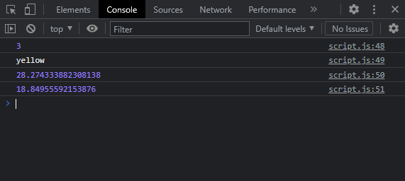

1. **Write a “person” class to hold all the details.**

class Person {

constructor(name,age,mobile,gender,course){

this.name = name;

this.age = age;

this.mobile = mobile;

this.gender = gender;

this.course = course

}

}

const karthi = new Person("Karthi","21","8681846217","Male","Web Development")

console.log(karthi);

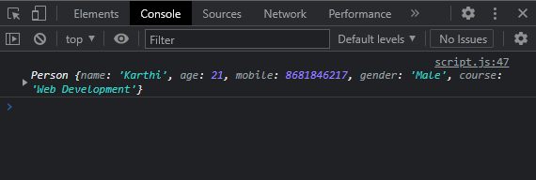

1. **write a class to calculate uber price.**

**class Uber {**

**constructor(name,location,distance){**

**this.name = name;**

**this.location = location**

**this.distance = distance;**

**}**

**getPrice(){**

**var pricePerKm = 3;**

**return `Fare is ${this.distance * pricePerKm}/-` ;**

**}**

**}**

**const user1 = new Uber("Karthi","Chennai",23);**

**console.log(user1.getPrice());**